Worksheet 6

Student Name: Aryan | UID: 25MCI10082
Branch: MCA (AI&ML) | Section/Group: 1/A
Semester: 2nd | Date of Performance: 01/03/2026
Subject Name: DBMS LAB | Subject Code: 25CAP-652

- Aim of the Session
Learn how to create, query, and manage views in SQL to simplify database queries and provide a layer of abstraction for end-users.
- Software Requirements
  - PostgreSQL (Database Server)
  - pgAdmin
  - Windows Operating System

- Objective of the Session
  - Data Abstraction: To understand how to hide complex table joins and calculations behind a simple virtual table interface.
  - Enhanced Security: To learn how to restrict user access to sensitive columns by providing views instead of direct table access.
  - Query Simplification: To master the creation of views that pre-join multiple tables, making reporting easier for non-technical users.
  - View Management: To understand the syntax for creating, altering, and dropping views, as well as the naming conventions required for efficient data access.

- Practical / Experiment Steps
Prerequisite Understanding
- Students should first understand that a View is a virtual table created from a SELECT query and does not store data physically.
- Students should understand the difference between base tables (which store data) and views (which display data dynamically from base tables).
- Students should create at least two related tables (for example, Employee and Department) to demonstrate simple and complex view creation.
- The base tables should contain:
- A unique identifier (Primary Key)
- Related columns for establishing relationships (Foreign Key)
- Descriptive attributes such as name, salary, or status
- Students should understand the concept of JOIN operations before creating multi-table views.
- Students should understand aggregate functions (COUNT, SUM, AVG) for creating summarized views.
- Students should be familiar with basic SQL commands including:
- CREATE VIEW
- SELECT
- CREATE OR REPLACE VIEW
- DROP VIEW
- Students should understand that views can be used as a security layer by granting access to the view instead of the original tables.

5. Procedure of the Practical
- Start the system and log in to the computer.

- Open PostgreSQL software.

iii) Create and select the database.
Create database Practical6;

(iv) Create table using DDL command.
create table Department (
dept_id serial primary key,
dept_name varchar(50)
);

create table EmployeeV (
emp_id serial primary key,
emp_name varchar(50),
salary numeric(10,2),
status varchar(20),
dept_id int references Department(dept_id)
);

(v) Insert records into the table.
insert into Department (dept_name) values
('HR'),
('IT'),
('Finance'),
('Sales');

insert into EmployeeV (emp_name, salary, status, dept_id) values
('Amit', 30000, 'Active', 1),
('Ankit', 45000, 'Active', 2),
('Khushi', 58000, 'Inactive', 2),
('Manisha', 40000, 'Inactive', 3),
('Arman', 70000, 'Active', 4);

(vi) Display all records.
select * from EmployeeV;
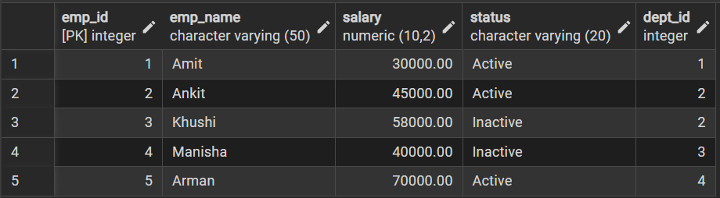

select * from Department;
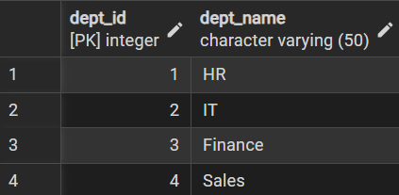

Step 1: Creating a Simple View for Data Filtering create view active_emp as
select emp_id, emp_name, salary, dept_id
from EmployeeV
where status = 'Active';

select * from active_emp;
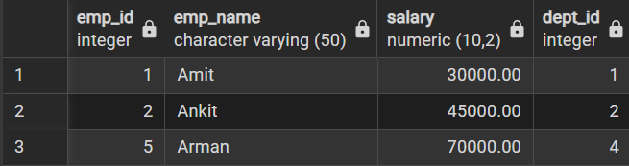

Step 2: Creating a View for Joining Multiple Tables
create view emp_dept_view as
select
e.emp_id,
e.emp_name,
e.salary,
d.dept_name
from EmployeeV e
join Department d
on e.dept_id = d.dept_id;
select * from emp_dept_view;
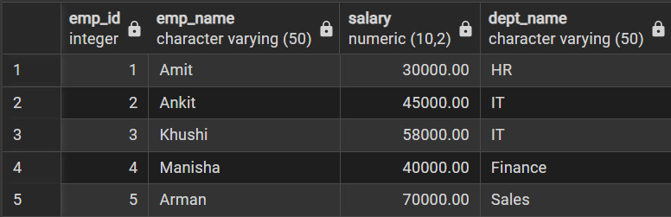

Step 3: Advanced Summarization View
create view dept_summary as
select
d.dept_name,
count(e.emp_id) as total_employees,
avg(e.salary) as average_salary,
sum(e.salary) as total_salary
from Department d
left join EmployeeV e
on d.dept_id = e.dept_id
group by d.dept_name;

select * from dept_summary;
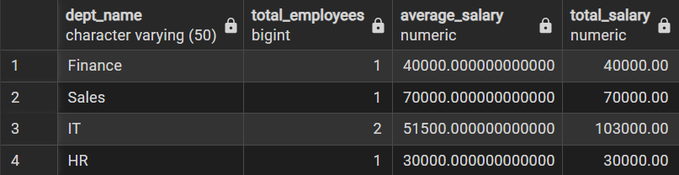

create or replace view active_employees as
select emp_id, emp_name, salary
from EmployeeV
where status = 'Active';

select * from active_employees;
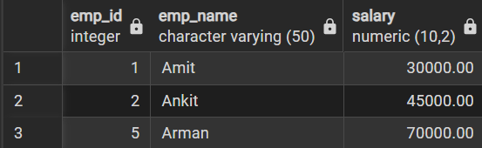

6. I/O Analysis (Input / Output) Input:
- Creation of base tables such as Employee and Department
- Insertion of sample records into base tables
- SQL queries used to create simple and complex views
- JOIN operations applied within view definitions
- Aggregate functions (COUNT, SUM, AVG) used in summary views Output:
- Virtual tables (Views) created successfully without storing physical data
- Filtered employee data displayed through simple views
- Combined employee-department data retrieved using JOIN-based views
- Department-level statistical summaries generated automatically
- Simplified query results for reporting purposes
- Secure and controlled data access provided through view-based permissions
- Real-time updated results when underlying base tables are modified Screenshots of execution and obtained results are attached.
7. Learning Outcomes
- Abstraction Proficiency: Students will be able to create and query views to simplify efficient data access and abstraction.
- Security Implementation: Students will understand how to use views for data masking and providing restricted access to sensitive information.
- Syntactic Accuracy: Students will demonstrate the correct syntax for creating and querying views, ensuring logical clarity in naming conventions.
- Real-world Application: Students will be able to design views for practical domains like Library Management Systems or Payroll Systems to demonstrate functionality.

